CAFE DEPLOYMENT

### **Check whether IIS, nodejs and mysql installed on the server.**

We can check this in start menu by searching,

* iis (or) inetmgr
* Mysql
* Nodejs

If it is not installed, we need to download the softwares and install. For IIS we need to just enable it .

**Enabling IIS :**

go to control panel-> Turn windows features on or off -> Server manager will be prompted. In Add roles and features wizard,

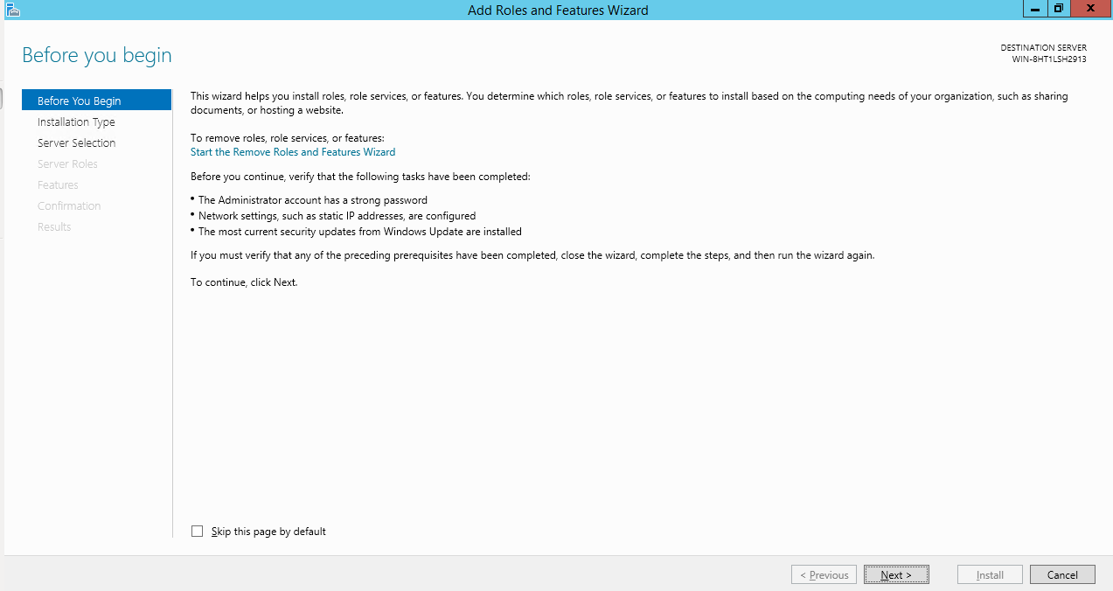

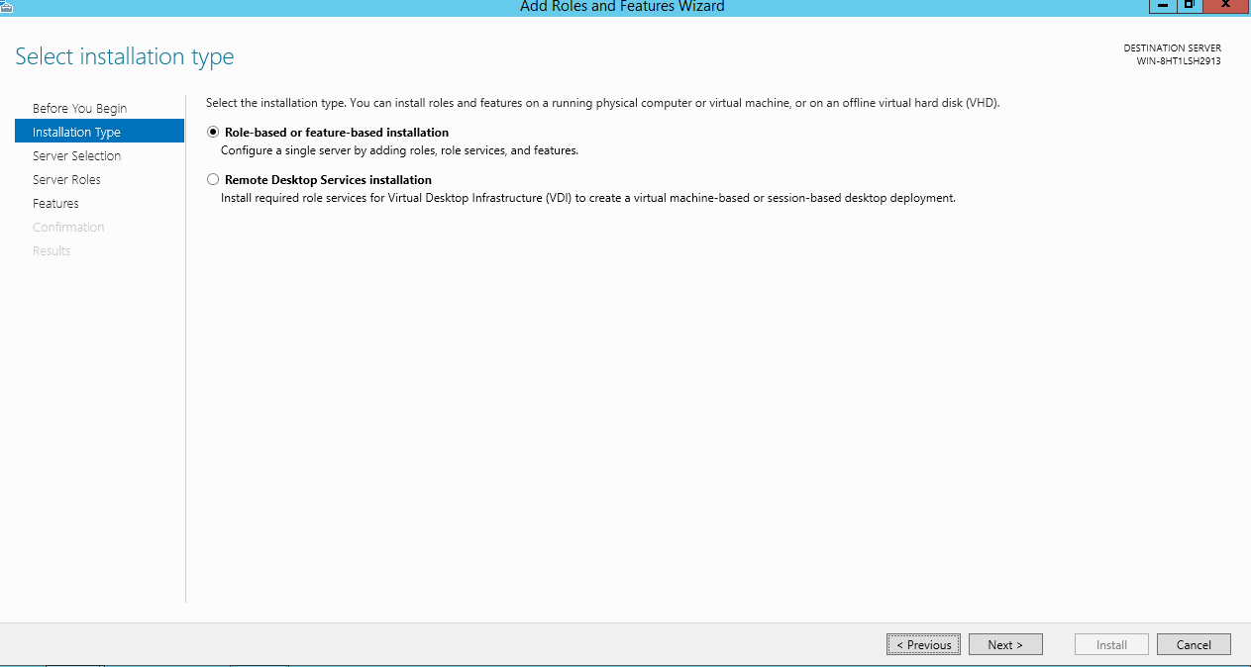

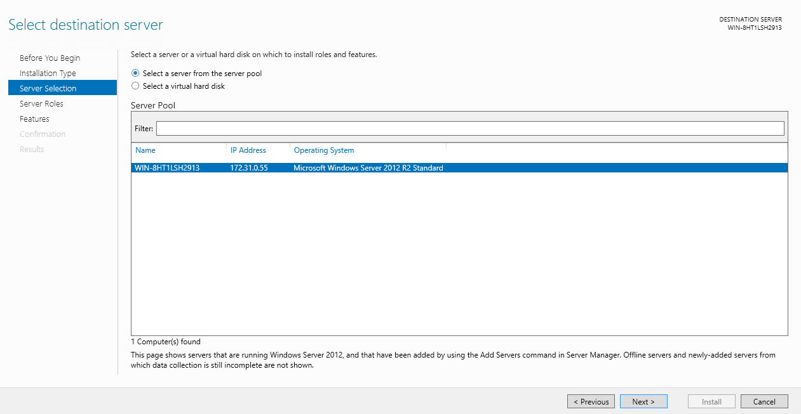

Select Web server (IIS) and Add features

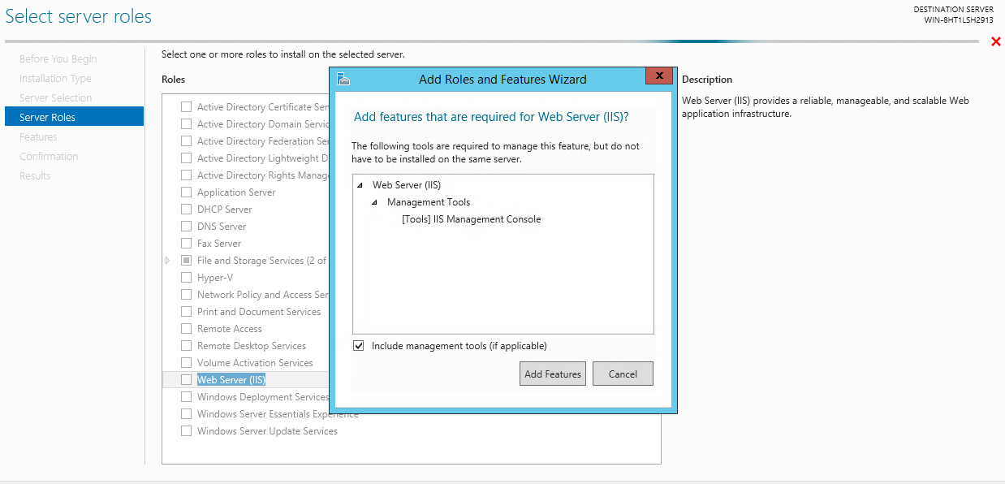

Select the below features and its child features,

* .NET framework 3.5 features
* .NET framework 4.5 features
* Remote server administration tools
* SMTP server
* Windows process activation service

Final step of installation should be like this,

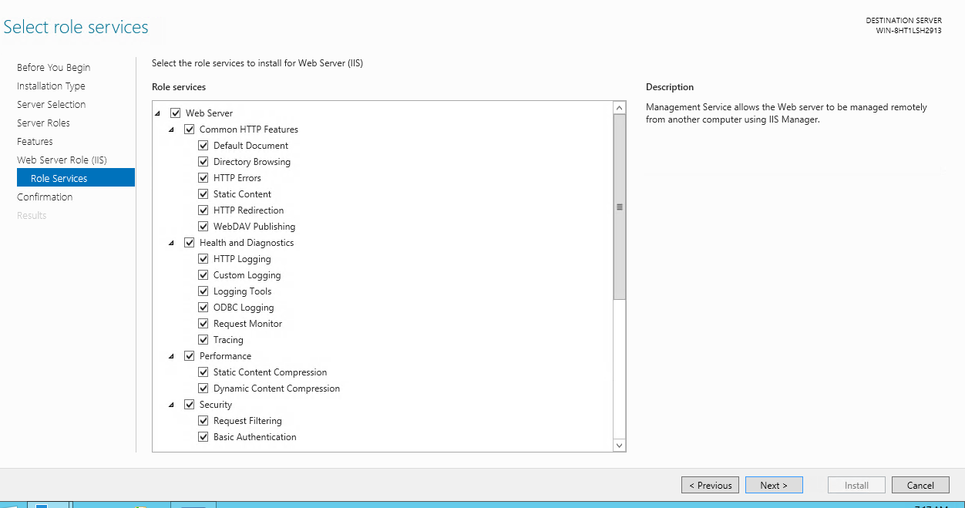

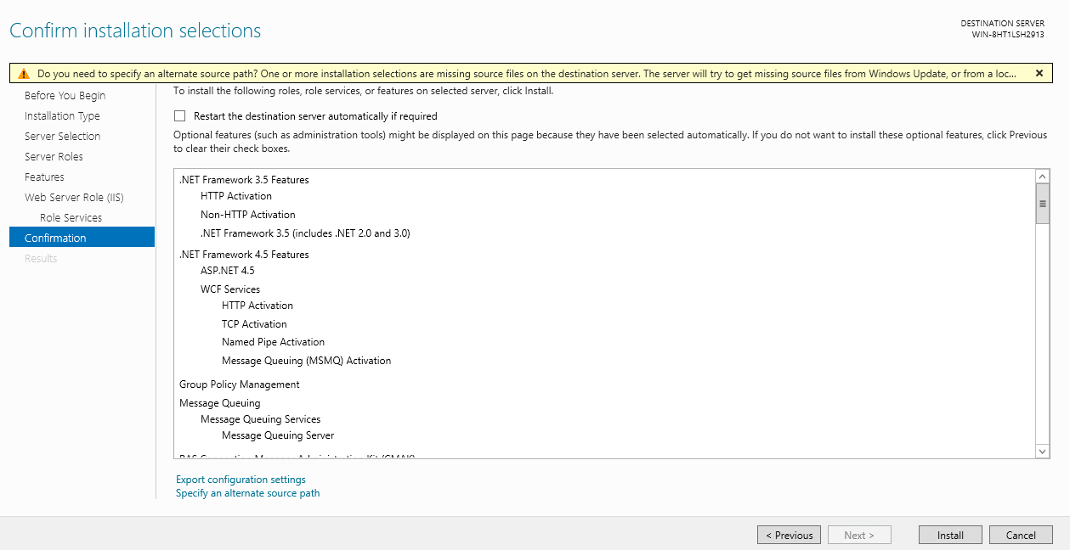

Once installed, search in start menu with IIS or intemgr, we will get results like below

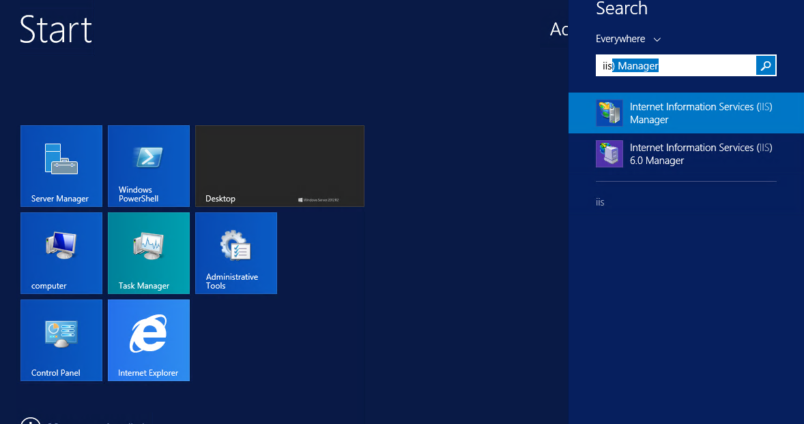

**Installing Mysql :**

Download Mysql 5.7 using the link <https://dev.mysql.com/downloads/windows/installer/5.7.html>

Select ‘Windows (x86, 32-bit), MSI Installer with 503.8M’ and select ‘No thanks, just start my download.’ in next page. It will start downloading the software.

Once it is downloaded, install it.

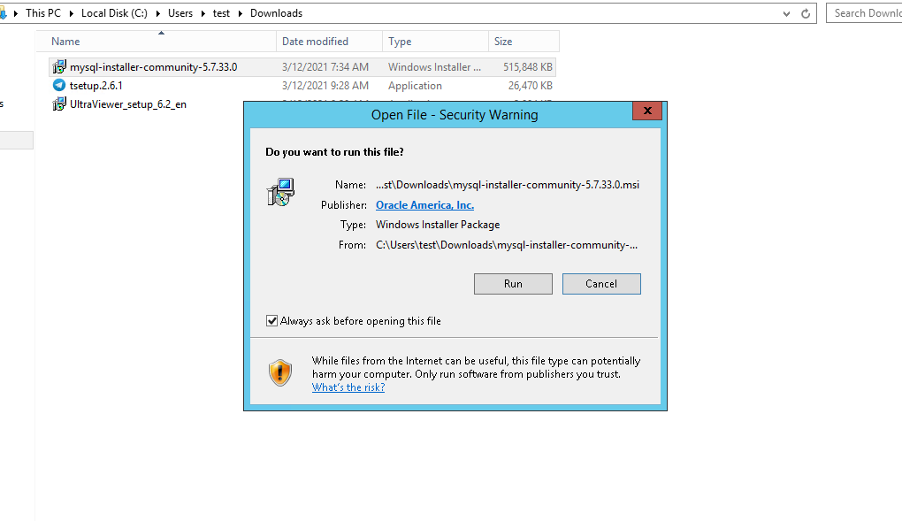

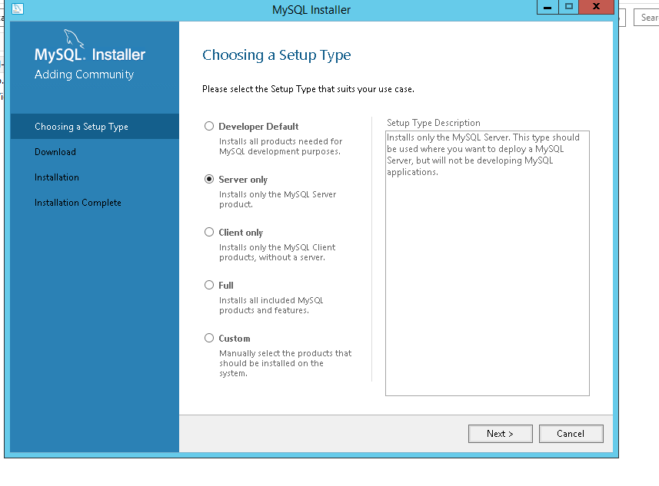

Click on execute and accept Visual c++ dependencies

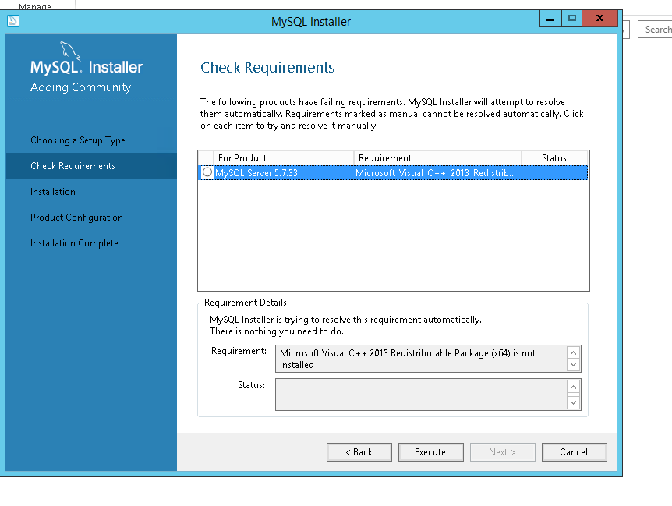

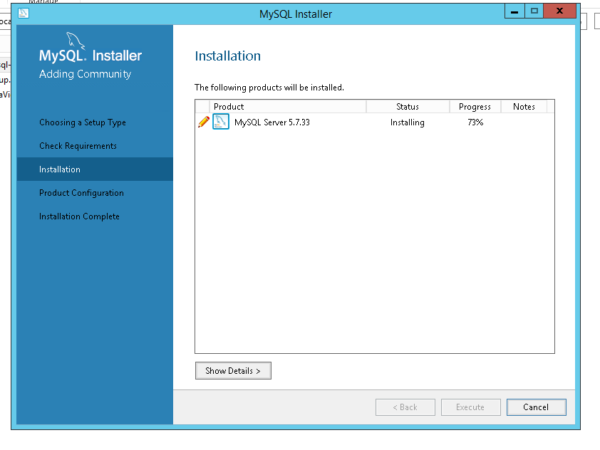

Set the root user password now. We need to share the db name and credentials to the developer, so that developer can use it in the code for db connection.

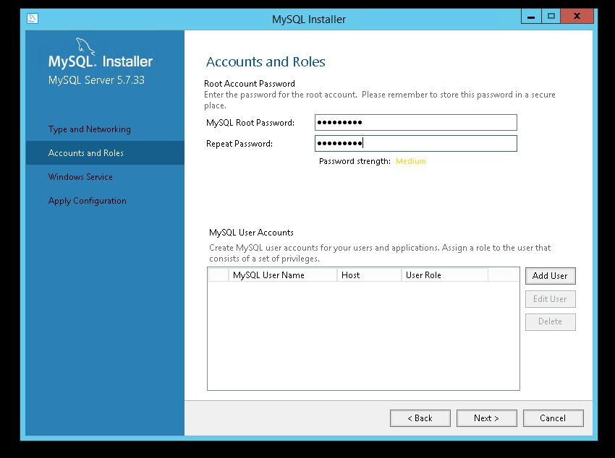

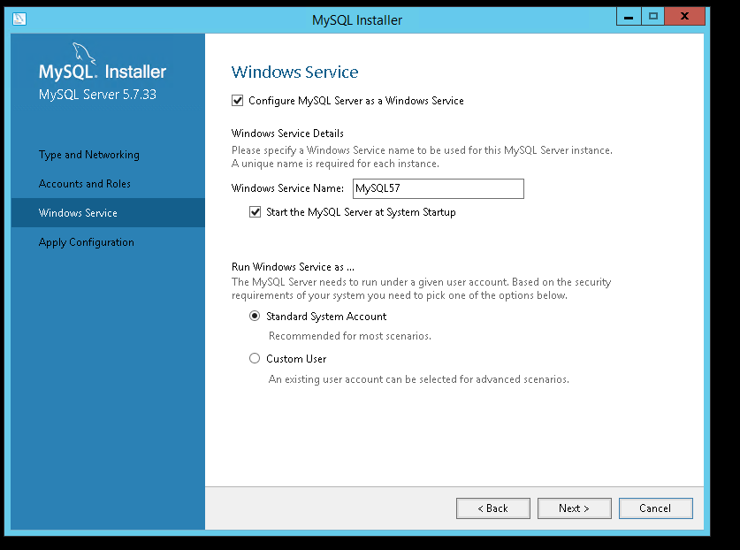

Click on execute

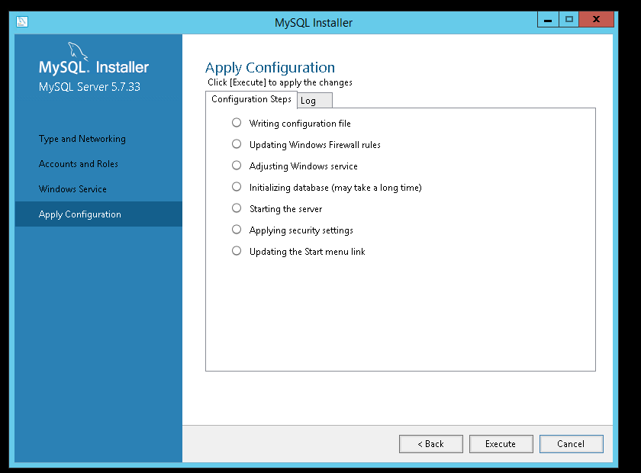

Open mysql installer in start menu

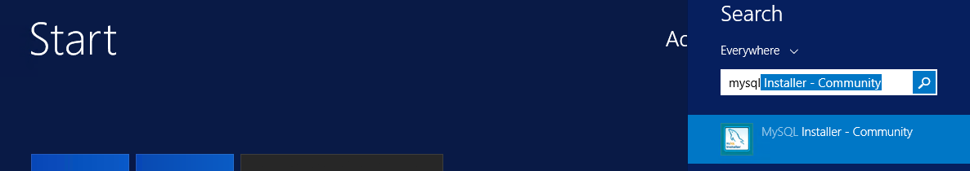

Click on add button to install mysql workbench

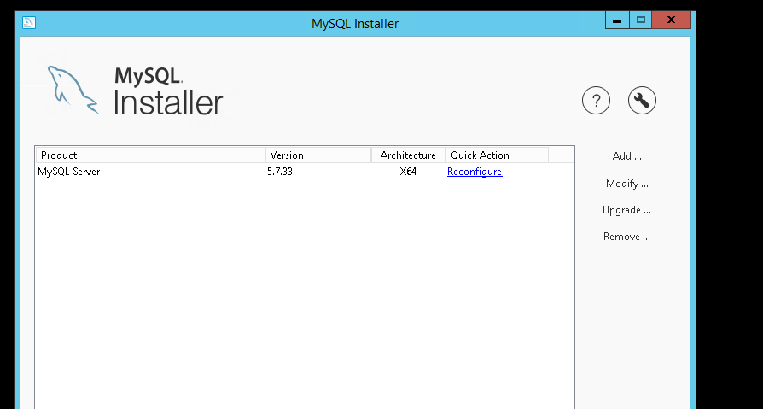

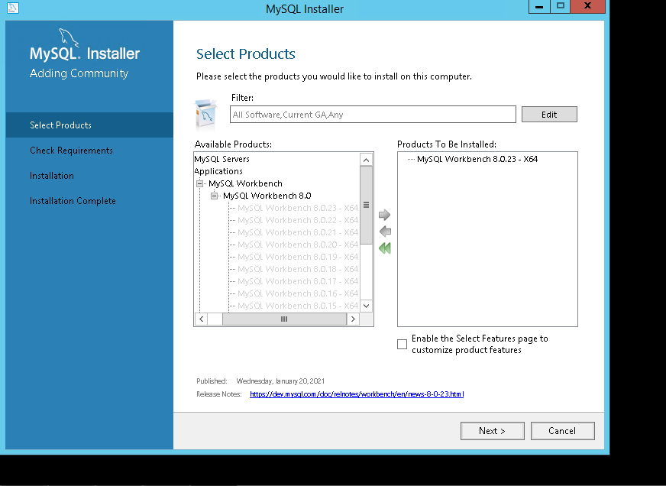

Installation is same like mysql installation. After installation mysql work bench will be launched. We need to create new connection and login with the root credentials.

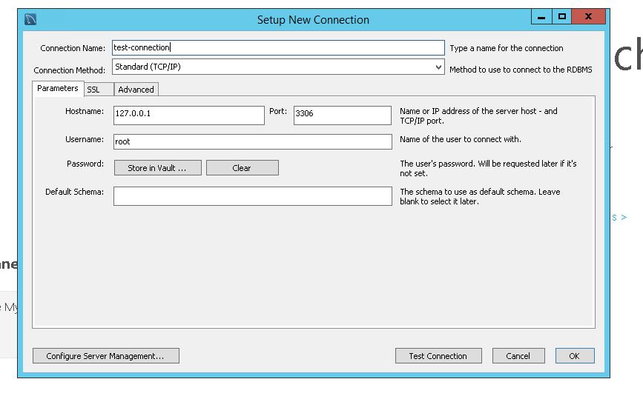

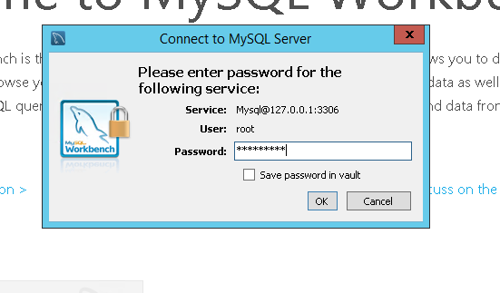

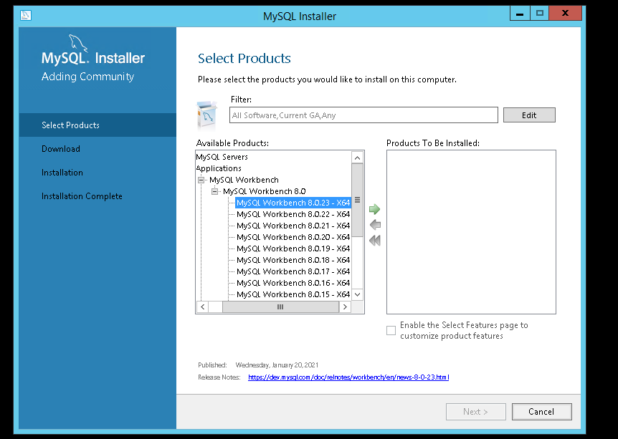

**Installing Node js 12 :**

Download the Node js 12 software from this link, <https://nodejs.org/dist/latest-v12.x/node-v12.21.0-x64.msi>

Install it, with default values in wizard.

We can confirm whether it is installed by searching in start menu.

Executel below commands in command prompt which will install angular, typescript and sails

* npm install -g @angular/cli
* npm i typescript
* npm install -g sails

Create “cms” folder in this path “C:\inetpub\wwwroot\”

Create a folder “cms frontend” inside cms and “dist” folder in cms frontend

Deploy the frontend build (webe folder) given by the developers, inside the “dest” folder .

Check below image

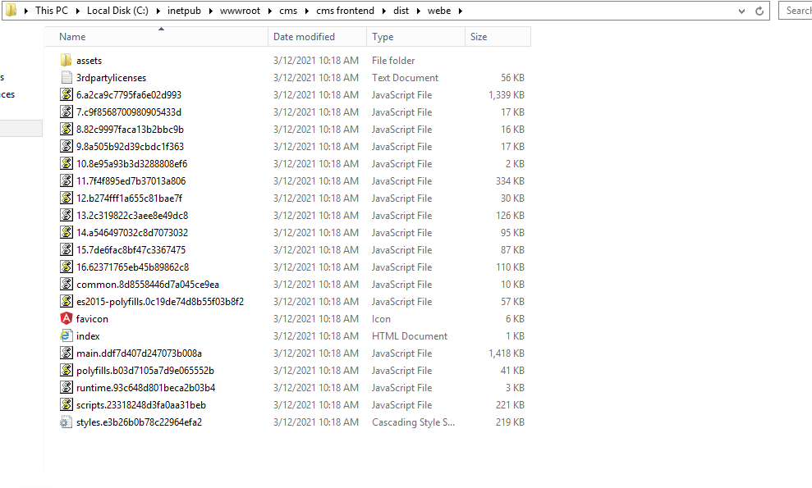

Create a folder “agile_backend” inside cms folder. Deploy the backend build given by the developer. Folder structure and backend files should be like in below picture,

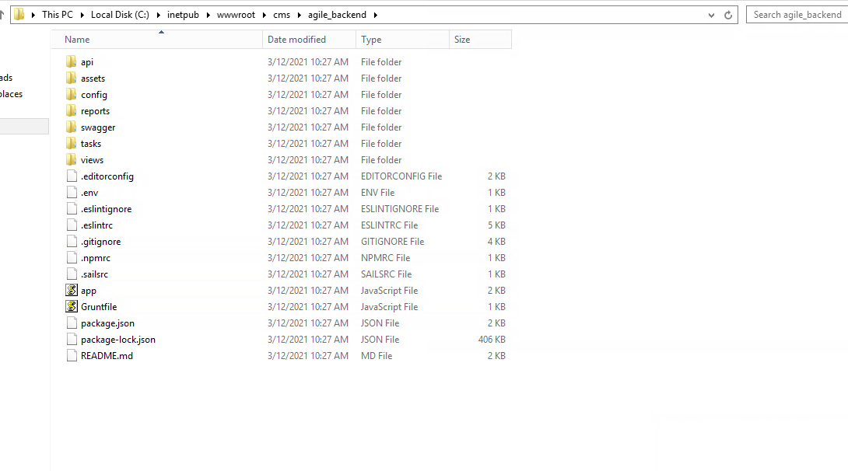

Creating db and deploy sql files in mysql. Open mysql workbench and connect to the mysql server with the root credentials we created.

Create a new schema (db) with the name “agile_production” and click on apply.

Once schema is created select Server -> Data import .

Select option “import from self contained file”. Browse the sql file which is given by developer.

Default target schema should be the schema (db) name “agile_production” which we created earlier and click on start import.

(refer below picture)

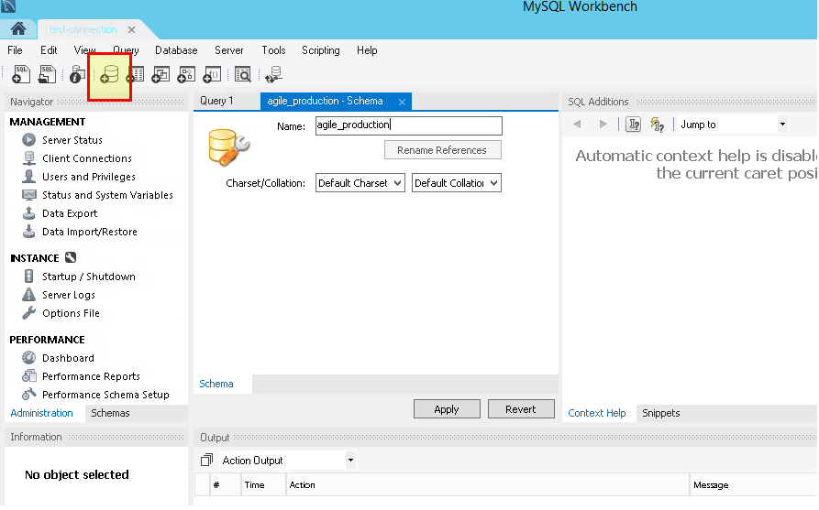

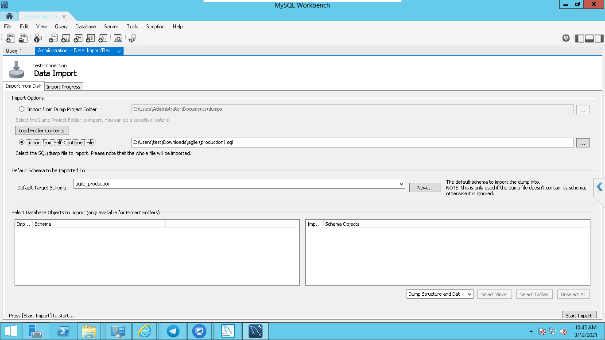

Once import completed we will get “1 of 1 imported”.

Now open IIS and create a new site.

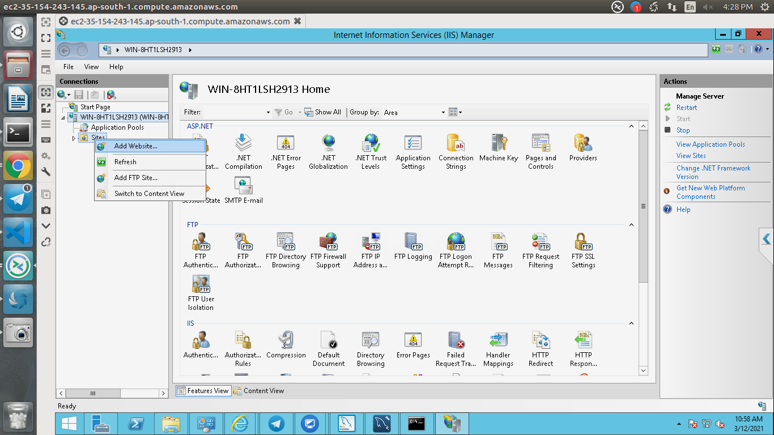

Create a new site with the name “cms”, application pools “cms”, physical path should be “C:\inetpub\wwwroot\cms\cms frontend\dist\webe” and port is 81.

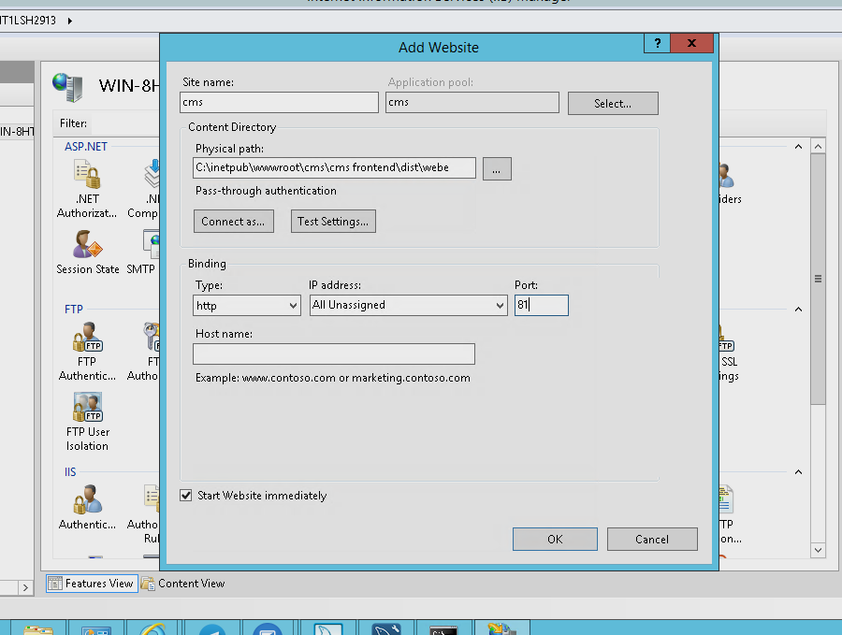

Right click on cms folder in “C:\inetpub\wwwroot” give full control to the users and IIS_IUSRS

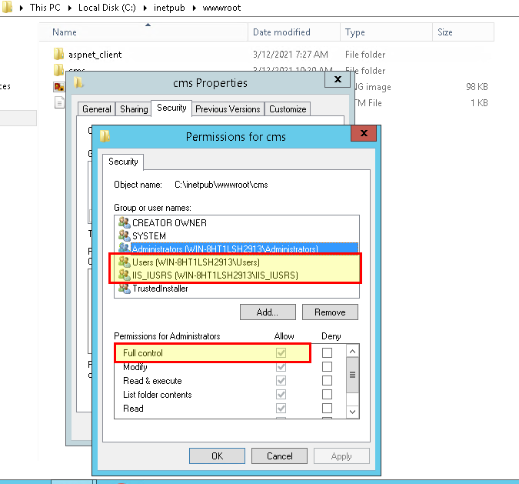

Now open the command prompt, and execute below commands

cd “C:\inetpub\wwwroot\cms\agile_backend”

npm install

sails lift

We should see the output like below,

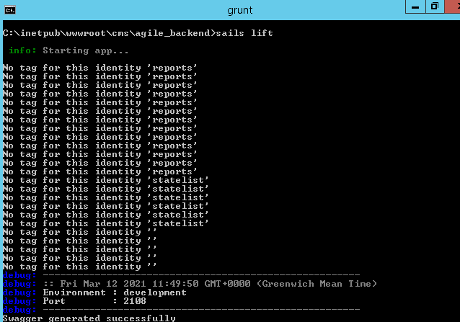

sails lift

Open the chrome browser and hit the <http://localhost:81> url, we should see the page like below

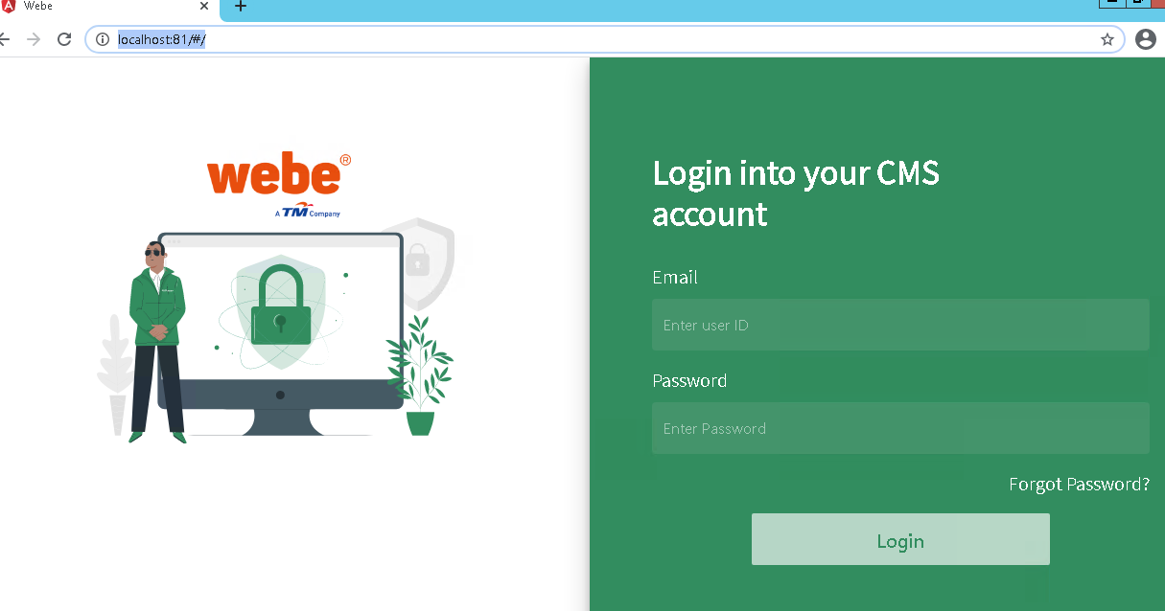

Enter the credentials and login.

